**Requirement Management Report for the Case Study**

**“Green Groceries Online Platform”**

**Section A**

**1. Introduction about Online Green Groceries Platform**

Green Market, a well-known local company that deals in importation of organic and locally obtained grocery products, is in the high-scale program of developing an e-commerce platform. This platform aims at fueling the company to reach the wider marketplace and to offer sustainable products to a broader audience. With a stable business model developed from working with the local farmers and eco suppliers, the Green Groceries platform sees the online availability of the products as the driving force to future development.

As their mission is to take advantage of all the opportunities that technology can provide, Green Groceries has selected System Concepts (SC) as their business confidante in the area of software development. System Concept, a software firm that is renowned for its prowess in utilization of Agile method and SCRUM begins to resemble Green Groceries with the company's goal of flexibility, responsiveness and nurturing collaboration when it comes to development.

This teamwork merges the Green Groceries, and System Concepts, this combining team from the start, with the uniqueness of the allocation of positions. The project is a one-man show of the Green Groceries' CEO and Founder who is engaged in the process of conceptualizing and actualizing it. Director of finance and operations are responsible for financial and operational running of the business. Along with development team System Concepts provides engineers skilled in development having Millie, Peter, Anita, Cheryl, and Pat. Their collective ability to develop informative website with helpful tools as well as their knowledge on Agile approaches and efficient communication is expected to yield a dynamic online platform that signifies Green Groceries’ dedication to sustainability. Further ahead of us starts a new challenge: the transition to Agile methodology as an alternative to the waterfall bottlenecks of the past. Agile methodology values adaptability, teamwork and iterative cycles, and is therefore well suited not only for the volatile context of software development, but also fits Green Groceries values.

Over the coming three months, work is about trying to set up an online platform together with the Green Groceries and System Concepts teams that not only bring the project's business objectives to real life but also speaks for the brand's healthy environment-oriented style. The Agile methodology will be a major factor in the ensuring the success of the plan by building a solid basis for the Green Groceries Online Platform development based on the collaborative and responsive environment.

**2. Drawback of Traditional Software Development Methodology**

Drawbacks of Website Development for Green Grocery:

User Experience (UX) Issues:

* The site lacks a proper navigation structure which are easy to look at and understand. Finding particular product can be difficult and also not finding the category is a difficult task also by users.
* Browsers who feel more and more annoyed with the slow loading times may decide to leave the webpage (bounce rates will increase).
* Inconsistent font and color combinations annoy users.

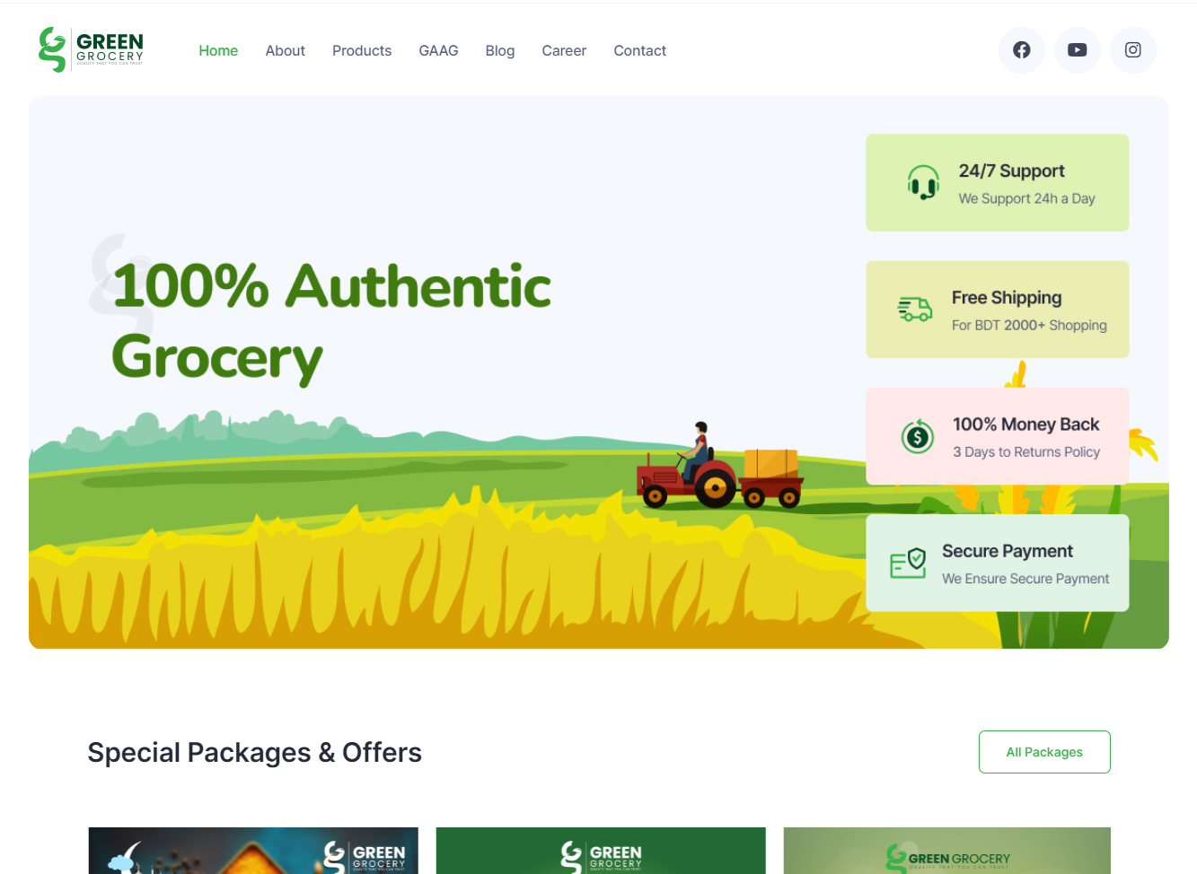

Mobile Responsiveness:

* The unadapted screen website may not fit your screen sizes well as it does. The handset user may face layout issues and also the questions concerning navigation whereas the feature phone user may be limited to a particular service.

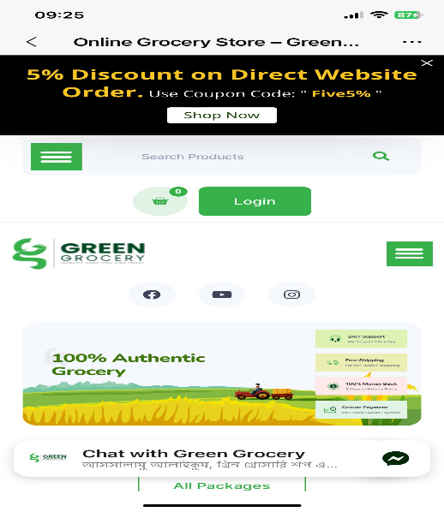

Limited Product Information:

* The product descriptions may seem sharp but they by no means carry all the critical facts. The public is demanding valuable information so they can make smart choices.

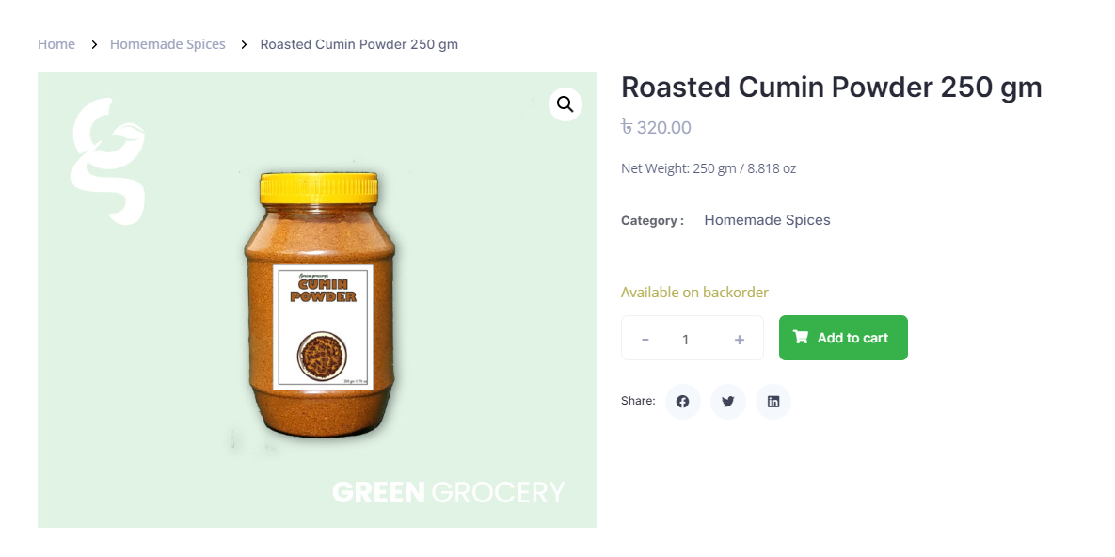

Checkout Process:

* Some buyers would see the checkout to be slow. By simplifying it, one reduces the embarrassing outlay problem of the customers and boosts their shopping experience.
* The inability of shoppers to make payments with the use of variety of means (for instance, credit card or digital wallet) can scare off potential customers.

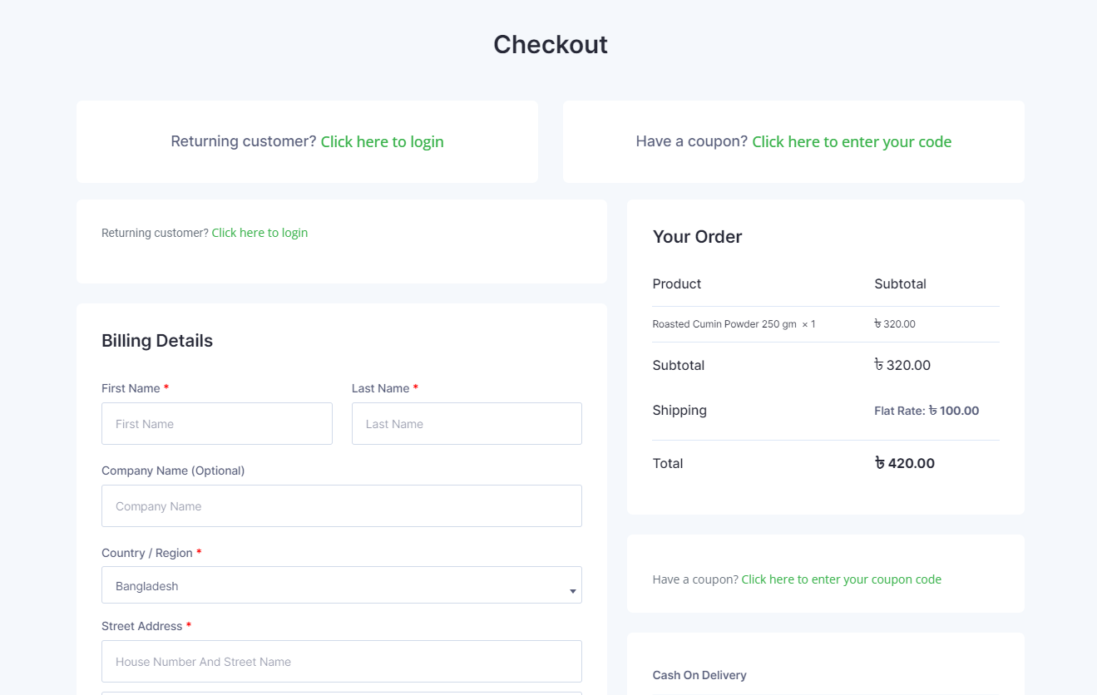

**3. Agile Frameworks Methods and its Overview.**

**Rapid Application Development (RAD):**

RAD stands for rapid application development, where this is a stepwise, iterative, and agile software development methodology that puts first a small window of development and evaluation cycle. It is a highlight of the fact of its user feedback and involvement in the development process. RAD is trying to come up with adaptive prototyping fast and using regular feedbacks to improve the product quality.

**Prototyping:**

The prototyping process involving building a simplified system in the initial step. This prototype is used to get user approval and crystalize requirements before construction and implementation of the system. It allows stakeholders to imagine and to connect with the product soon during the epoch of its development process, therefore diminishing the risk of misunderstandings.

**Timebox Approach:**

Timeboxing is an interpret project management method applied to tasks or activities having a predefined timebox at each stage. It provides assistance in meeting work scope within time frames. That contributes to focus and aids in right management of deadlines and scopes.

**Joint Application Development (JAD):**

Joint Application Designs (JAD) is a teamwork method which includes participation of each stakeholder, end users and applications designers in orderly consecutive workshops. Sessions review the requirements, discuss the design and make the decisions collectively. When there is a joint application development (JAM) between a tester and a developer it leads to improved communication, diminishing of ambiguities and an increased pace in the process of application building

**Sprint and Scrum:**

Scrum is an Agile methodology that breaks a project into definite iterations called sprints. Most were tune to 2-4 weeks long. Scrum is discovery, cooperation, and constant improvement at its heart. As a result, the teams can take on a shippable product increment at the final stage of each sprint.

**Dynamic Systems Development Method (DSDM):**

DSDM is an Agile manner of delivering projects effectively and rapidly so quality is ensured. It concentrates on the user interaction, fast-time production providing of services, as well as changing requirements modification. DSDM puts a lot of stress on teamwork, constant checking and communicating.

**Facilitated Workshops:**

The facilitated workshop is a process of collaborating with all stakeholders and getting an expert development team together in a given and carefully thought out environment to resolve specific issues. Workshops can be instructed on diverse issues related with the project, for instance, participants may need to be trained on soft skills like requirements gathering, planning, or problem-solving. The leader of the group ensures that good communication and involvement of all participants are well taken care of.

**4. Systematic Workflow of Green Groceries Online Platform done with**

**Agile Method:**

**5. Merits of using Agile Concepts**

1. Flexibility and Adaptability:

Agile methodologies like Scrum or Kanban institutions flexibility as a priority and are competitive in case of requirements amendments. It is this agility that enables the rapid adjustment of shifting priorities, customer requirements and market trends, which are essential to creating a truly personalized experience. Agile development which involves a cycle wait also this gives the great opportunity of continuous improvement and adjustment to the entire project undertaking procedure.

2. Customer Collaboration and Feedback:

Productivity is the main purpose of Agile, customers must be closely involved in the product development process. Feedback from stakeholders - especially end users is collected during activity rounds, then continuously integrated into the development process. In this way, we can ensure that our customers can closely compare the finished product with their original ideas and thus it delivers success and a high level of satisfaction.

3. Faster Time-to-Market:

Agile methods, in particularly, pivot on a continuously evolving process, which combines working and fully functional software (sprints) that are released on a time-box basis and often are within two weeks. It offers shorter release cycles hence users don’t have to wait for long to access valuable features as compared to older technologies. The faster time-to-market is a must in the industries and companies with trends that change very quickly and intense competition like fashion or video games sector.

4.Improved Risk Management:

Agile offers the risk management practice an immediate rather than passive approach. Manage through inspection and retrospective during process iterations make it is possible for teams to be on the look-out and take care of the issues early. Agile is cyclic in formulation which serves as an on-stop risk-resolver by breaking the project into smaller, manageable iterations that can easily be changed as risks occur.

5. Enhanced Team Collaboration and Morale:

Agile methodologies build burger on collaboration and communication among the cross-functional teams. The routine ceremonies such as daily stand-up, sprint planning, and retrospectives render a common understanding of the scope and the status of a project to be shared among the team members. Such atmosphere strengthens the team spirit, promotes sharing knowledge among the members, and also creates a feeling of having ownership of the process and being accountable for it.

6. Continuous Improvement:

The frameworks that are agile intensify the culture of constant-development. Every time the cycles are finished, individuals carry retrospectives to be able to think about what went well and present the improvements as well as the methods for streamlining processes. It enables the evergrowing convergence toward a better way of functioning, a more productive team, a higher quality product, and general project success.

7. Increased Transparency:

Save the project transparency as an important feature by not only communicating what is done well and what is not but also showing project issues and goals to all stakeholders. Instances like Kanban boards or Scrum boards avoid wonders and give you an instant view of the state of the tasks and the goals. This single unit provides a window of insight into various intricate functions and processes, develops trust among team members and stakeholders, which inevitably drives to superior collaboration and decision-making.

**Section B**

**High Level Requirements Analysis using MOSCOW rules**

**B1. Base line requirement review**

**B1.1. Given requirement analysis using MOSCOW rules:**

|  |  |  |  |
| --- | --- | --- | --- |
|  | Requirements | Moscow rule | Reasons |
| 1 | As an Order Handling Clerk, I want to use the website to process telephone purchases, replacing the paper-based system. | Won’t have | Because the application can be used on smart phones, there is no need to call to place an order. |
| 2 | Maintain at least 20 office plants as part of the company's commitment to a green and healthy workspace. | Could have | Office plants and good practices for healthy workspaces should not be an important attribute of the online platform's functionalities. The main goal of this platform is to give users the opportunity to buy organic grocery items online. While this would be nice, it won't have any consequences on the basic elements of the site. |
| 3 | As a customer, I want to be able to change my account details to ensure my most up-to-date information is recorded. | Must have | The ability to change account details from the customer's side is vital for the efficiency of the account detail maintenance. This, it immediately addresses the user’s need to exercise control over their account information. |
| 4 | Organize a virtual celebration on the website for the CEO's birthday to showcase the company's fun and friendly culture. | Won’t have | is not a core requirement for the online platform's functionality. |
| 5 | As the Managing Director I want to be ensured that the site is Data Protection Act safe so that we do not get fined hundreds of thousands of pounds. | Must have | Legal compliance is critical to avoid financial penalties. The company will face dire consequences due to not complying with the data protection regulations, this one is non-negotiable. The monetary and the legal repercussions put this first. |
| 6 | As a customer register an account. | Must have | customer registration is the first step of the platform engagement providing personalized experiences, order tracking, and disable user preferences. This functionality enables to leading a client-focused platform and the creation of lasting customer relationships. |
| 7 | As a Customer I want a choice of delivery slots so that I can arrange my diary appropriately. | Should have | Giving customers the option of delivery time helps improve customer experience and time flexibility. |
| 8 | As a customer, I want to be able to modify my shopping cart so that I can change my mind about what I want to buy. | Should have | Cart modification is a feature that, in most e-commerce platforms, contributes to user convenience. |
| 9 | The company should adopt pet-friendly policies to create a positive and inclusive work environment. | Won’t have | it's not directly related to the core functionality of the online platform. |
| 10 | The system must be designed to handle a 30% increase in traffic during peak periods without degradation in performance. | Must have | Essential for providing a seamless user experience and preventing potential disruptions. |
| 11 | As a customer, I want to enter separate delivery and invoice addresses so that I can receive bags when staying at a friend’s house. | Should have | While not as important as must-have features, it significantly contributes to a positive user experience. |
| 12 | As a Customer I want to be able to change my account details so that my most up to date details are recorded. | Could have | Office plants and good practices for healthy workspaces should not be an important attribute of the online platform's functionalities. The main goal of this platform is to give users the opportunity to buy organic grocery items online. While this would be nice, it won't have any consequences on the basic elements of the site. |
| 13 | As an Order Handling Clerk I want to use the Web site to process telephone purchases so that I can stop using the paper-based system. | Won’t have | Because the application can be used on smart phones, there is no need to call to place an order. |
| 14 | As a customer, I want to choose whether or not I am sent marketing information to avoid receiving excessive junk mail. | Could have | While it provides users with better experience and meets customer demands, the must-haves are more essential. Through this innovation the customer experience will improve and customer satisfaction may be raised. |
| 15 | All user data, including personal information and payment details, must be encrypted to ensure the highest level of security. | Must have | Security is the main concern, especially when sensitive user information is included like personal data and payment details that should always be protected. Encryption mechanism provides security of personal data from unauthorized access and compliance with data protection laws convincing clients. |
| 16 | Maintain consistent branding elements and design across the website to reinforce their brand identity. | Should have | Brand consistency is indeed important for the sake of recognition and the building of trust but is is one of the must-haves because it is more related to aesthetics and branding than the core functionality of the online platform. |
| 17 | The development team should participate in a team-building event every quarter to foster collaboration and a positive work environment. | Won’t have | Team-building activities are important for company culture but are outside the scope of the online platform development. |
| 18 | As the Marketing Director I would like an offers or discount page so that we can inform our customers of the aforementioned. | Should have | This feature contributes to your marketing and customer acquisition strategy but is not essential for the basic operation of the online platform. |
| 19 | As the Chief Accountant I want to the Web site to adhere to legislation regarding VAT so we are not hit with a hefty fine. | Must have | Complying with VAT-related laws is important to avoid legal problems and possible fines. Ensuring compliance with tax regulations is a basic requirement to protect a company's financial health. |
| 20 | As the Operations Director, I want to accept all forms of payment to capture the largest market possible. | Should have | Payment flexibility is an important aspect for customer convenience. |

**B1.2. Update High Level Functional Requirements**

|  |  |  |
| --- | --- | --- |
| **ID** | **High level functional requiement** | **Reason** |
| **1** | The user interface of the web site must be friendly and easy to use as well as be compatible with different devices (a computer, mobile phone or a tablet). | With the increasing use of various devices, ensuring compatibility across platforms enhances accessibility, usability, and overall user experience. |
| **2** | Advanced Search: Agile search tool that supports filtering products by various criteria, such as price, category, brand, reviews and so on. | Flexible search engine with advanced filtering capabilities gives users a more personalized and efficient shopping experience. |
| **3** | Develop more detailed product categories that will be helpful for the users to discover new items. | Detailed product categories aid users in navigating the website and discovering new items. Improved classification makes it easier for users to locate products of interest. |
| **4** | Enables the customer to evaluate and give feedback on products, this makes information more reliable and ensures credibility. | Integrating a rating and review system provides users with valuable information, helping them make informed decisions. This feature enhances transparency and fosters a sense of community among users. |
| **5** | Makes it easy for shoppers to compare different products to determine which ones are quality. | This functionality enhances the user's ability to assess product attributes, leading to higher customer satisfaction. |
| **6** | Integrated order tracking feature: Users can monitor the order progress, get delivery notifications and be in constant touch with a support team. | This instills confidence in customers, reduces anxiety about order status, and allows them to plan for product arrivals. |
| **7** | Provides a power for customers to scan QR codes for payments at physical shops. This strengthens in-store shopping and forms an integrated experience between online and offline. | Integrating QR codes makes payment more convenient for customers. They only need to scan the code to receive payment, enhancing the customer's shopping experience. |
| **8** | Display items related or similar to those that viewers see while they add an item in a cart. This gives shoppers the power to explore in a new way and to shop. | This feature provides a personalized touch to the shopping experience, making it more engaging and dynamic for users. |
| **9** | Enables users to keep a list of goods they like and shop anytime they need to. | This feature creates a personalized shopping experience, enabling users to easily revisit and purchase their preferred items, leading to increased user engagement and loyalty. |